* **Lab Task 3**

Display the Airline Name and calculate the number of months since the hire date (using the flight table's hire_date).

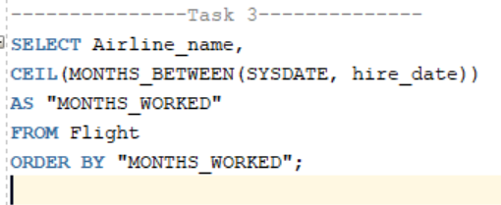

Output:

